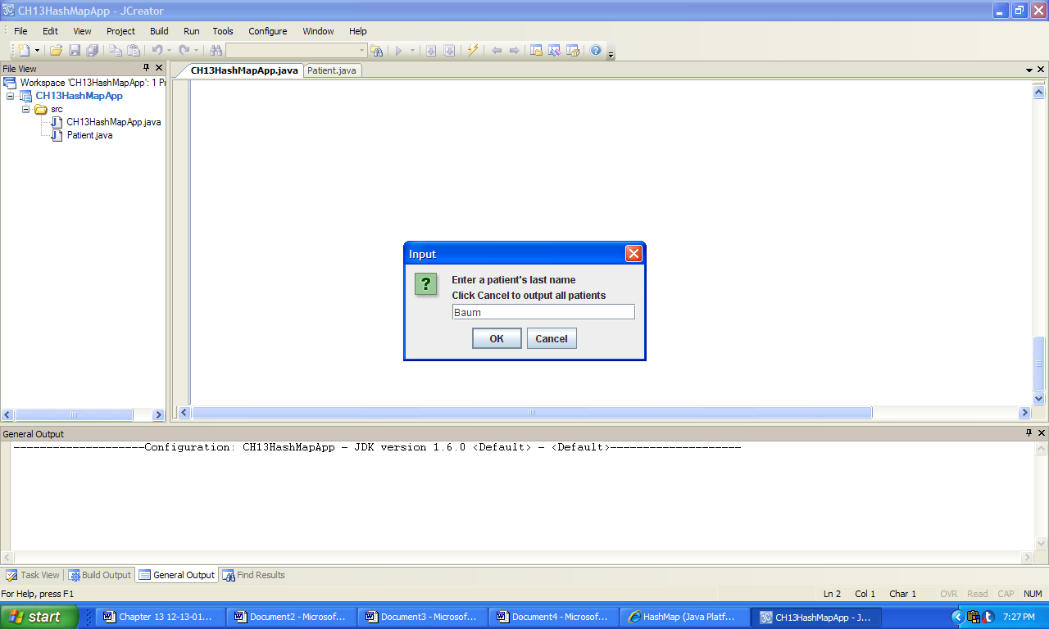 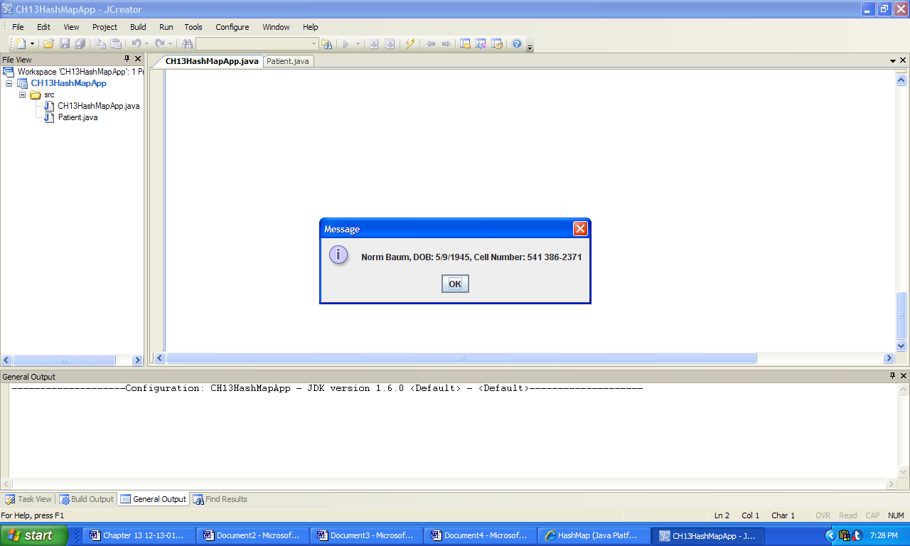

a) b)

*Console Output:*

Amy Adams, DOB: 8/5/1991, Cell Number: 643 531-2283

Norm Baum, DOB: 5/9/1945, Cell Number: 541 386-2371

Tom Jones, DOB: 2/3/1989, Cell Number: 643 976-4545

Ray Rondo, DOB: 2/6/1998, Cell Number: 643 736-2949

**Figure 13.35 An input and outputs produced by the application TreeMapApp.**